UNITED STATES

SECURITIES AND EXCHANGE COMMISSION

Washington, D.C. 20549

SCHEDULE 14A

(Rule 14a-101)

INFORMATION REQUIRED IN PROXY STATEMENT

SCHEDULE 14A INFORMATION

Proxy Statement Pursuant to Section 14(a) of The Securities Exchange Act of 1934

(Amendment No. )

Filed by the Registrant ☐

Filed by a Party other than the Registrant ☒

Check the appropriate box:

- Preliminary Proxy Statement

- Confidential, for Use of the Commission Only (as permitted by Rule 14a-6(e)(2))

- Definitive Proxy Statement

- Definitive Additional Materials

- Soliciting Material Under Rule 14a-12

GRIFFON CORPORATION

(Name of Registrant as Specified in Its Charter)

VOSS VALUE MASTER FUND, LP

VOSS VALUE-ORIENTED SPECIAL SITUATIONS FUND, LP

VOSS ADVISORS GP, LLC

VOSS CAPITAL, LLC

TRAVIS W. COCKE

H. C. CHARLES DIAO
(Name of Persons(s) Filing Proxy Statement, if Other Than the Registrant)

Payment of Filing Fee (Check the appropriate box):

- No fee required.

- Fee computed on table below per Exchange Act Rules 14a-6(i)(1) and 0-11.

- Title of each class of securities to which transaction applies:

- Aggregate number of securities to which transaction applies:

- Per unit price or other underlying value of transaction computed pursuant to Exchange Act Rule 0-11 (set forth the amount on which the filing fee is calculated and state how it was determined):

- Proposed maximum aggregate value of transaction:

- Total fee paid:

- Fee paid previously with preliminary materials:

- Check box if any part of the fee is offset as provided by Exchange Act Rule 0-11(a)(2) and identify the filing for which the offsetting fee was paid previously. Identify the previous filing by registration statement number, or the form or schedule and the date of its filing.

- Amount previously paid:

- Form, Schedule or Registration Statement No.:

- Filing Party:

- Date Filed:

Voss Value Master Fund, LP, a Cayman Islands limited partnership (“Voss Value Master Fund”), together with the other participants named herein (collectively, “Voss”), has filed a definitive proxy statement and accompanying BLUE proxy card with the Securities and Exchange Commission (“SEC”) to be used to solicit votes for the election of its highly-qualified director nominee at the 2022 annual meeting of stockholders of Griffon Corporation, a Delaware corporation (the “Company”).

Item 1: On January 28, 2022, Voss issued the following press release:

Voss Comments on Griffon’s Confirmation of Involvement in Candidate Withdrawals

Voss Clarifies the Rigorous Process Undertaken to Recruit Highly Qualified and Independent Director Candidates, Including Engaging a Reputable Search Firm and Conducting Extensive Interviews with Multiple Nominees

HOUSTON, Jan. 28, 2022 /PRNewswire/ -- Voss Capital, LLC ("Voss"), a significant shareholder of Griffon Corp. (NYSE: GFF) ("Griffon" or the "Company"), today issued a statement regarding Griffon’s admission of the Company’s involvement in the withdrawal of Voss’s two director nominees.

Voss’s previous suspicions of Griffon’s involvement in the withdrawals of our candidates have now been confirmed by the Company itself in its most recent letter. Two of Voss’s nominees underwent a lengthy approval process conducted by their employers’ executives and compliance departments, including at the parent company level. We have confirmation of the approval they received from their respective employers BEFORE accepting their nomination for Griffon’s Board. However, several weeks after the public announcement of their candidacy, their respective employers revoked their approval. Neither employer was able to provide a reason for the reversal at the time, but now we know why.

Griffon expressly admitted in their letter released on January 27, 2022, that they did indeed contact the employers of our candidates. We find it highly unusual that Griffon’s “representatives” contacted the parent company of each of our candidates’ employers – rather than the actual employers themselves. Surely this is because therein lies the personal connection that they were able to exploit to strong-arm our candidates out of the running.

In yesterday’s letter to shareholders, the Company claims we did not correctly vet our candidates. This could not be further from the truth. When we decided to move forward with this process, we commenced a rigorous search for highly qualified candidates. Voss hired executive search firm GLG Research to conduct a comprehensive search based on the specific experience we believed was needed on the Board. We then narrowed our list to 16 different candidates before conducting interviews and deciding on our chosen three.

We would much rather discuss the merits of our plan for value creation as presented in our deck and our candidate’s extensive qualifications than engage in a tit for tat on past events. However, we cannot allow Griffon to continue its campaign of misinformation on this topic. It would appear that Mr. Kramer’s boardroom buddies feel the same, as not a single independent director signed the Company’s recent letter on behalf of the Board. Unsurprisingly, the only other person to sign the letter beside the CEO was his employee and fellow insider on the Board– COO Robert Mehmel.

The fact that Griffon would go to such extreme lengths to force out our candidates, crossing ethical lines and disregarding shareholders’ right to a fair vote in the process, leads us to two conclusions.

1.) Griffon recognizes the strength in our case for change and is worried that our fellow shareholders will agree with our plan and vote for our candidate.

2.) Griffon is fully convinced that a truly independent Board nominee would, in fact, make a large difference in the boardroom and are terrified of finally being held accountable to shareholders.

Unfortunately, Griffon’s confirmation of tampering with our nominees seems typical, given the Company’s history of acting in opposition to shareholder interests. This proxy contest provides shareholders the opportunity to support meaningful change at Griffon and establish a candidate in the boardroom who will prioritize value creation.

If you have already voted Griffon’s white proxy card, a later-dated vote on Voss’ BLUE proxy card will revoke your previously cast vote.

For more information on our case for change, visit our website www.renovategriffon.com.

Media Contact:

Serena Koontz

Head of Investor Relations

Voss Capital, LLC

serena@vosscap.com

Investor Contact:

John Ferguson

Saratoga Proxy Consulting LLC

jferguson@saratogaproxy.com

Item 2: Also on January 28, 2022, Voss issued the following press release and open letter to stockholders:

Voss Capital Responds to Grossly Misleading Griffon Statements

Refutes Inaccuracies and Challenges Misleading Claims

Provides Evidence of Company’s Cherry-Picking of Metrics

Believes Griffon’s Numerous Erroneous Claims are Proof Shareholder Driven Change is Needed

HOUSTON, Jan. 28, 2022 /PRNewswire/ -- Voss Capital, LLC ("Voss"), a significant shareholder of Griffon Corp. (NYSE: GFF) ("Griffon" or the "Company"), today issued an open letter to Griffon shareholders, which responds to several misleading statements and mischaracterizations made by Griffon in its recent investor presentation.

Dear Fellow Griffon Shareholders,

We have been encouraged by the positive investor response to our recent presentation that highlights the urgent need for change at Griffon, including our step-by-step plan for unlocking the value that is currently shrouded by Griffon’s conglomerate structure, outsized management compensation and a lack of true Board independence.

Sadly, Griffon’s executive team and Board have been unwilling to acknowledge the need for change. Instead of providing logical, accurate responses to the issues we have raised, the Company has chosen to be confrontational since our very first meeting. The Company’s recently released investor presentation and letter attempt to mislead investors by cherry-picking benchmarks, metrics, and time periods. This is a blatant attempt to justify executives’ oversized compensation and the Company’s value destructive strategy. The Company also failed to address several key issues raised in our deck including chronically low ROIC, the lack of margin expansion at CPP, sustained underperformance relative to peers, peer-leading management compensation, dismal of say-on-pay results, and ISS’s and Glass Lewis’ repeated criticisms of the company’s corporate governance and compensation. Below we highlight just a few of the deceptive and outright false statements the Company has made.

GRIFFON FALSE CLAIM #1

“Purposeful strategy to create a balanced portfolio… the five-year evolution of our business that led to the sale of our Plastics division in 2018 continues with the review of strategic alternatives and sale process underway for our Defense Electronics business, which began in April 2021, and our successfully completed acquisition of Hunter Fan Company.”

The Company intimates that it has undergone a deliberate strategic portfolio repositioning over the past few years with the sale of Plastics and the recently announced sale of Defense. The reality is the Plastics divestiture was the result of an unexpected and unsolicited inbound offer.

“Look, we weren't looking to sell Clopay Plastics… Let me be clear. We're responding to an inbound inquiry on the sale of Clopay Plastics.” – CEO Ron Kramer on M&A Call September 6th, 2017

Furthermore, Griffon oversaw a 38% decline in Defense revenue before announcing a sale. Had selling Defense been part of some deliberate value creation plan, the Company would have sold Defense before such a large decline. The proposed sale now is merely a long overdue recognition that the Company has not properly run that business, and a belated attempt to recover some value for it.

The Company also attempts to paint a picture that it was busy during 2021 selling Defense Electronics and pursuing Hunter Fan. Yet, according to the Company’s own Proxy Statement, the Finance Committee which is “responsible for reviewing proposed transactions that will materially impact the Company’s capital structure, as well as any material changes to the Company’s capital structure” did not meet even once during Fiscal 2021.

GRIFFON FALSE CLAIM #2

The company touts margin expansion and says the current margin improvement strategy at CPP has delivered “meaningful gains.”

It is easy to improve margins through buying higher-margin businesses, such as Hunter Fan. What Griffon’s deck neglects to demonstrate is what proportion of margin improvement is actually attributable to high-margin acquisitions versus internal improvements once a company was acquired. We suspect internal improvements are relatively small, as shown by results at CPP.

The Company has discussed expanding margins at CPP for at least a decade during which time there has been zero sustained margin improvement. This management team has no credibility when it comes to forecasting their own business and continues to make baseless promises that they are clearly unable to fulfill.
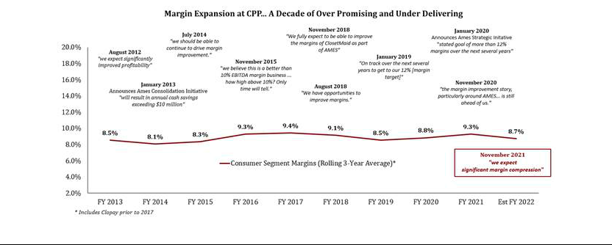

GRIFFON FALSE CLAIM #3

“Voss’ interests are not aligned with those of other shareholders.”

We own the same stock as every other Griffon shareholder. We are seeking what every shareholder is seeking: value creation. If anyone is not aligned with other shareholders, it’s the Griffon management team who is incentivized with bonus metrics that directly conflict with shareholders’ best interests. Despite owning a significant amount of Griffon stock, their actions only seek to protect the ~$30 million per year they receive to maintain the status quo at the expense of Griffon shareholders. In other words, why should they work to create value for all shareholders when they will be paid handsomely either way? With a negative TSR over the last five years despite an ongoing housing and remodeling boom, it is clear this management team and Board lack the ability to create sustainable value. Management’s herculean effort to keep any truly independent Board members out of the boardroom is indicative of its fear that an independent member would provide stronger oversight, including of executive pay.

GRIFFON FALSE CLAIM #4

“Our corporate function provides immense value to our operating companies… M&A expertise, strategic direction and executive leadership.”

This is LinkedIn-style corporate jargon devoid of substance. The Company is clearly unable to quantify any discernable value that the conglomerate structure provides. Of the nearly $50 million in annual corporate overhead expense, over 60% is compensation for the top four named executive officers at Griffon despite each of the underlying businesses having fully built out management teams. For example, CPP has a segment President as well as its own COO, CFO, General Counsel and Corporate Controller. We wonder what level of “executive leadership” is needed when each segment already has all the necessary functions covered, and if this executive leadership is worth the $50 million per year it’s costing us as shareholders.

GRIFFON FALSE CLAIM #5

“Griffon has consistently engaged in good faith with Voss”

The company’s approach to our engagement has been anything but “in good faith.” Following our meeting with Griffon Board members on November 9th, both sides agreed to send each other several information items, as well as the framework for a settlement agreement. Within 72 hours, Voss followed through on our commitment, sending both the requested information and a proposed settlement agreement. We never received the agreed upon information or a counteroffer from the Board. It was only after this lack of responsiveness that we decided to highlight our concerns publicly.

GRIFFON FALSE CLAIM #6

The Company shows its TSR under current management’s tenure as 431% compared to 316% for the Russell 2000.

This statement demonstrates either pure mathematical incompetence or a deliberate attempt to mislead shareholders, neither of which can be construed positively.

First, Griffon’s total shareholder return is not 431% over this time frame as shown on slide 42 in their presentation, but is in fact 100 percentage points lower at 331%.

Second, the Company is comparing its already inaccurate total return number to the simple price return of the Russell 2000 – not its total return. The Russell 2000 total return is over 65 percentage points higher than the price return the Company shows. This misleading apples-to-oranges comparison to understate index returns is a tactic the Company uses throughout the presentation, including on slide 11.

Third, in every annual report for the past 17 years, the Company has compared its total shareholder return to the S&P 600 index, never once mentioning the Russell 2000 index. The reason Griffon chose to now switch to the Russell 2000 in this presentation is clear: Griffon’s total shareholder return has underperformed its own self-selected broad benchmark, the S&P 600, by 72% under management’s tenure and by 66% over the past five years.

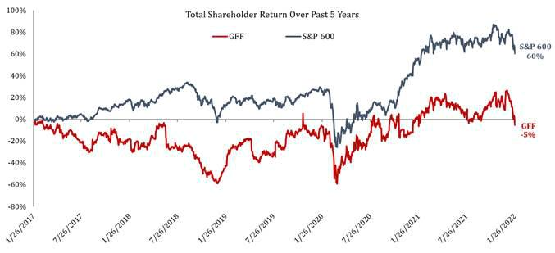

GRIFFON FALSE CLAIM #7

“Voss has no plan and is only interested in making a “quick buck””

Our recent investor presentation devotes an entire section, 11 pages, to our five-part plan. Our plan clearly lays out a path to unlocking over $50 per share in value for Griffon shareholders and includes sustainable operational improvements, cost-cutting initiatives and an optimized corporate structure.

By contrast, the Company continues to offer shareholders the same old strategy which has generated poor shareholder returns and low ROIC, with unfathomably high overhead.

Throughout their presentation, the Company touts “$60 million returned to shareholders since September 2018.” This equates to $1.06 per share. So, while it hasn’t been “quick”, a “buck” more aptly describes what Griffon management has provided to shareholders over the past three years. It’s also worth noting $60 million is far less than what the two top executives have personally pocketed over the same period.

GRIFFON FALSE CLAIM #8

Management has proven it can “shine a light” on HBP’s value as part of Griffon’s portfolio

There is a difference between “shining a light” and taking action. Mr. Kramer is continually telling shareholders that he believes HBP is worth a “mid-teens” EBITDA multiple. However, HBP never has and never will receive that valuation under Griffon’s existing conglomerate structure. The Company’s presentation included a chart showing an extensive list of recent transactions that have occurred in the building products space. The median 11.8X EV/EBITDA multiple of those transactions is on par with our projection for what HBP could realize in a sale. Such a multiple reinforces our view that the company must explore all strategic options for its HBP segment in order to realize its value.

With the value of the business now clear, we urge the Board to fulfill its fiduciary duty to all shareholders to maximize value by exploring all options.

GRIFFON FALSE CLAIM #9

“That success, however, could be derailed by the election of the nominee from Voss Capital LLC to our Board, which we believe would disrupt Griffon’s substantial progress and business momentum, and diminish the quality and strength of our Board.”

Griffon’s Total Shareholder Return is -5% over the last five years. How is that “substantial progress?”

The idea that one board member out of 14 could “derail” a company’s progress is laughable but we do appreciate the Company’s acknowledgment that our candidate Charlie Diao would in fact be able to exert influence in the Boardroom.

This complacent Board badly needs a true independent director. Mr. Diao brings experience chairing key committees on public company boards, realizing value for shareholders through M&A, and leading corporate development initiatives.

GRIFFON FALSE CLAIM #10

“Griffon’s Board is Focused on Governance Matters and Responsive to Shareholder Feedback” “Griffon has proactively engaged with shareholders around ESG.”

The reality is Griffon has not been responsive to shareholder concerns surrounding executive compensation. Despite the benefit of the insider ownership, as well as its large ESOP Plan, the Company has seen recurring shareholder dissatisfaction over its pay practices. The Company only spoke to shareholders owning 9% of outstanding shares in all of 2021. This is a surprising fact considering the number of Griffon institutional shareholders that have not only voted against Say on Pay, but also against unopposed incumbent Board members.
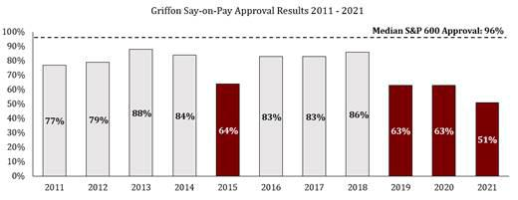

We also find the Company’s claim of responsiveness on governance matters to be a misleading characterization of minor changes made only after our suggestions. One touted improvement is reducing the special meeting threshold to 25%. This appears to be a hollow attempt to placate shareholders, especially considering the Company retains super-majority voting provisions. Furthermore, according to the Company’s own proxy statement, the Nominating and Corporate Governance Committee only met once in all of Fiscal 2021. It wasn’t until Voss engaged with the Company and recommended numerous governance reforms that the Company acted.

Conclusion

In this letter we have discussed what is in Griffon’s presentation. Perhaps even more interesting is what is not in the Company’s presentation. The Company never once addressed many of the most important shareholder concerns, including chronically low ROIC, the lack of margin expansion at CPP, sustained underperformance relative to peers, peer-leading management compensation, dismal say-on-pay results, and ISS’s and Glass Lewis’ repeated criticisms of the company’s corporate governance and compensation.

We believe Charlie Diao will provide a much-needed independent voice and oversight in the boardroom. He will provide value from day one.

Vote the BLUE proxy card to send the message to Griffon’s leadership and Board that shareholders deserve better. Vote the BLUE proxy card to support a nominee who will hold management accountable and who has experience focusing on the right data, metrics, and incentives to drive real value creation for all shareholders.

More information on our case for change, plan for value creation and voting instructions can be found on www.renovategriffon.com.

Sincerely,

Travis Cocke

Chief Investment Officer

Voss Capital

Media Contact:

Serena Koontz

Head of Investor Relations

Voss Capital, LLC

serena@vosscap.com

Investor Contact:

John Ferguson

Saratoga Proxy Consulting LLC

jferguson@saratogaproxy.com

Item 3: Also on January 28, 2022, Voss updated the website www.renovategriffon.com, copies of the webpages are set forth below:
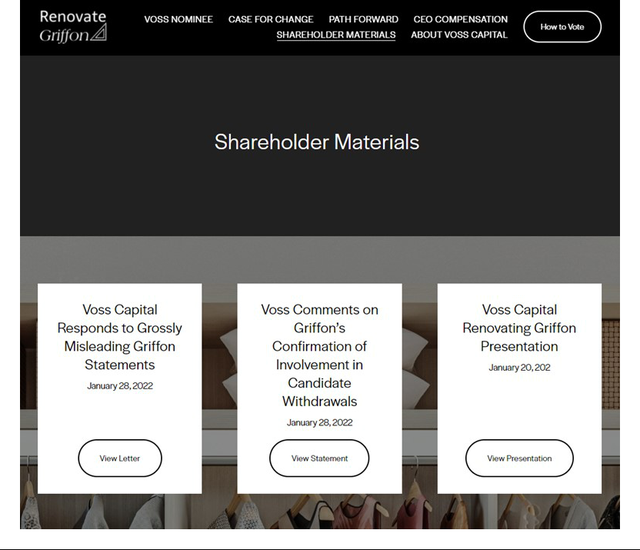

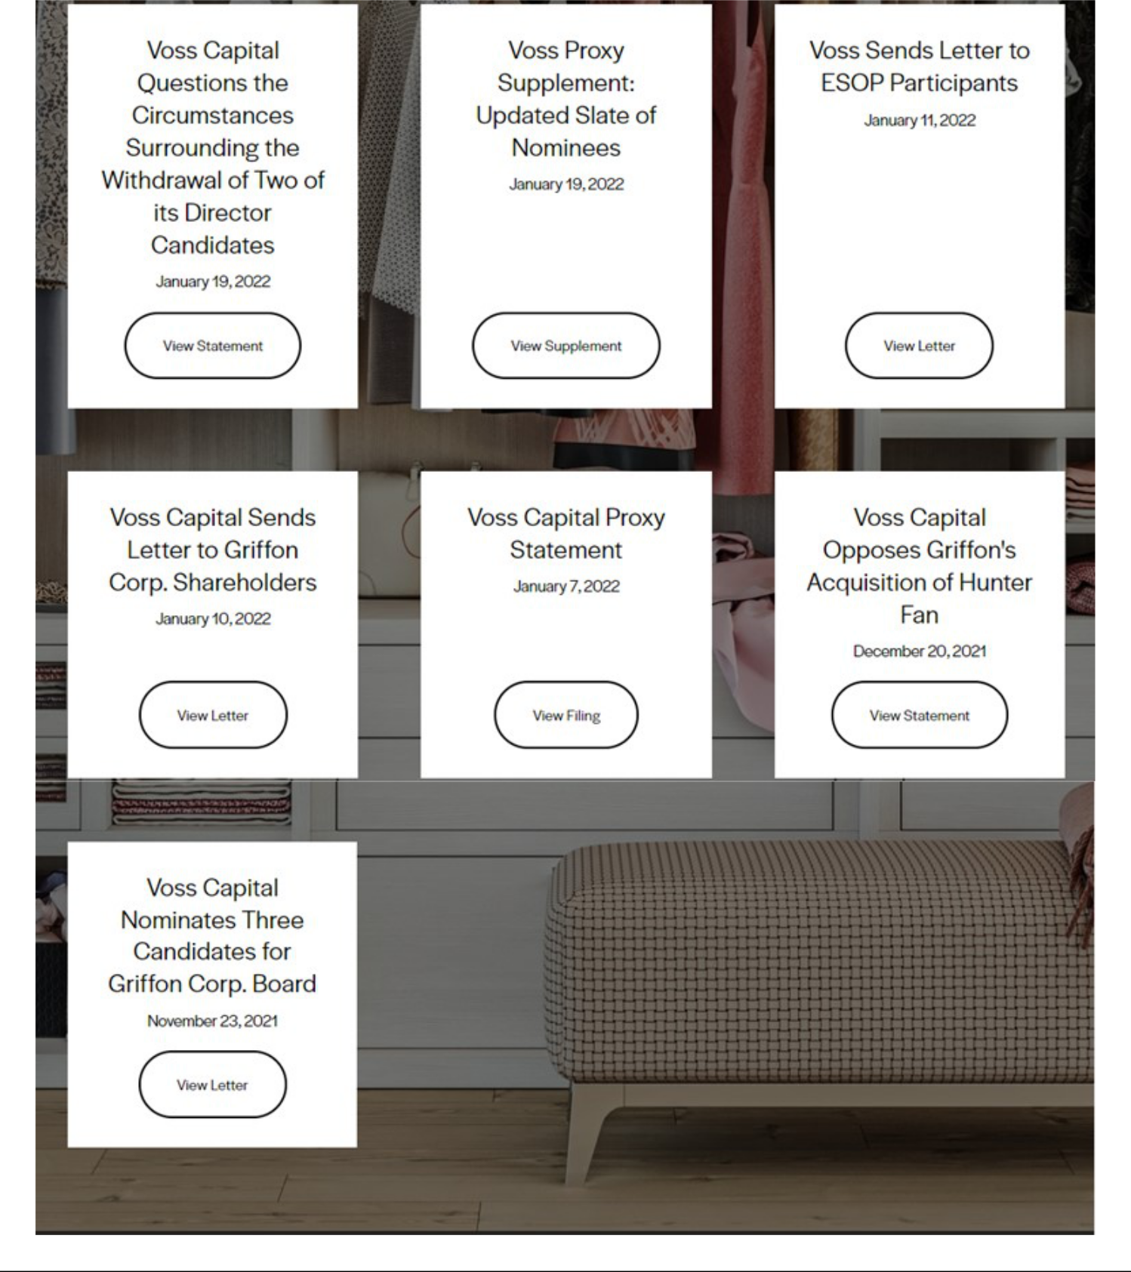

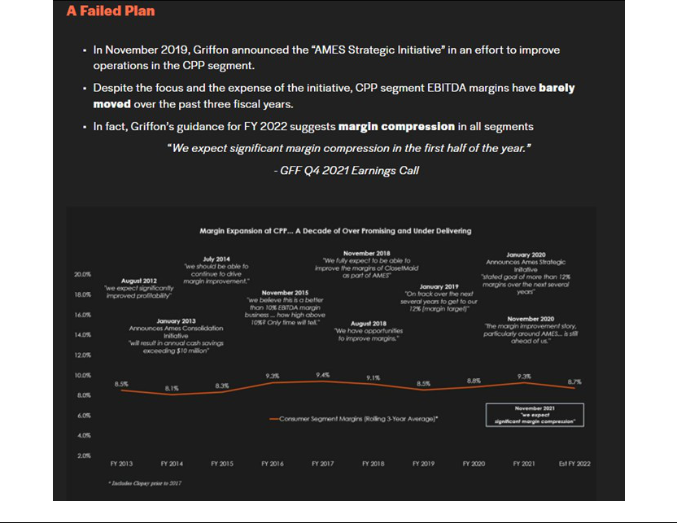

Item 4: Also on January 28, 2022, Voss issued the following statements via social media:


